SENTINELSHIELD
ADVANCED INTRUSION DETECTION & WEB PROTECTION SYSTEM

Submitted by: SHIVANAND MALLIKARJUN

Course: CYBER SECURITY

Subject: Cyber Security / Web Security

1. Aim

The aim of this project is to design and implement a lightweight Intrusion Detection and Web Protection System that inspects HTTP requests, detects common web attacks, logs malicious activity, and prevents brute-force behavior using rate limiting. The project helps in understanding how real-world Web Application Firewalls (WAFs) work.

2.Objective

- To understand how web attacks occur

- To detect SQL Injection and XSS attacks

- To implement request inspection

- To log malicious activities

- To prevent brute-force attacks using rate limiting

3 Tools & Technologies Used

- Python
- Flask Web Framework
- Command Prompt
- Web Browser (Chrome)
- Text Editor (Notepad / VS Code )

Project Description

SentinelShield is a simplified Intrusion Detection and Web Protection System developed using Flask. It inspects incoming HTTP requests and checks user input against predefined attack patterns such as SQL Injection and Cross-Site Scripting (XSS). When malicious behavior is detected, the request is blocked and logged. Rate limiting is implemented to prevent brute-force login attempts.

5. System Workflow

- User sends an HTTP request

- SentinelShield inspects request parameters

- Attack detection rules are applied

- Rate limiting monitors request frequency

- Malicious requests are blocked

- Security events are logged

6. Implementation Steps

- Installed Python and Flask

- Created a basic Flask web application

- Added attack detection rules

- Implemented logging functionality

- Added rate limiting mechanism

- Tested the system using normal and malicious requests

Experimental Results with Screenshots
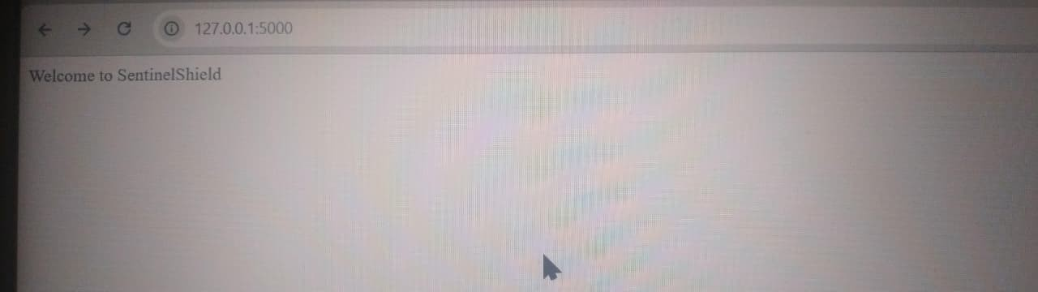
Figure 1: SentinelShield home page loaded successfully.
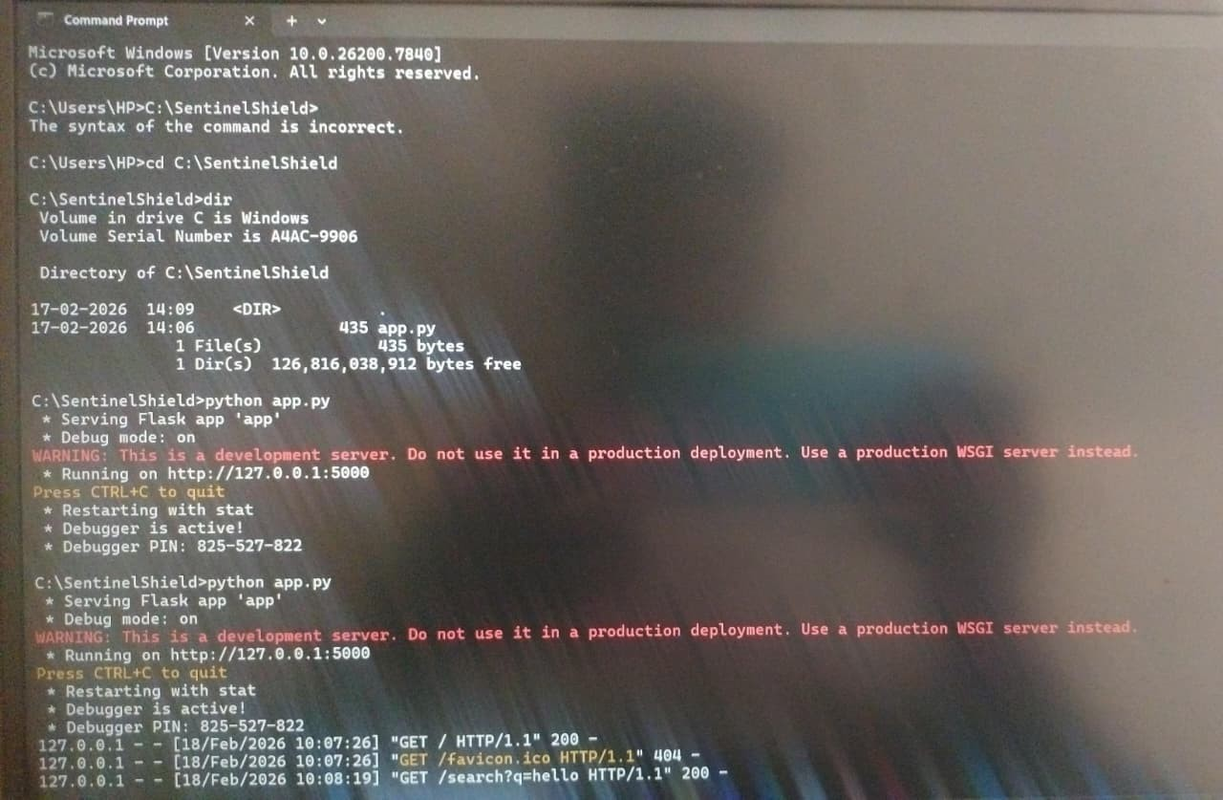
Figure 2: Flask server running successfully in Command Prompt.
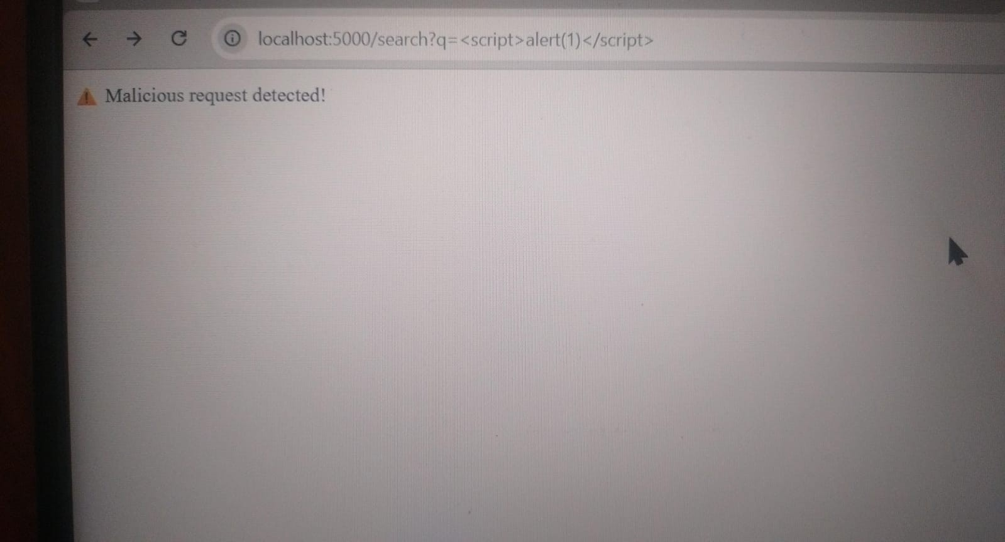
Figure 3: Cross-Site Scripting (XSS) attack detected and blocked.
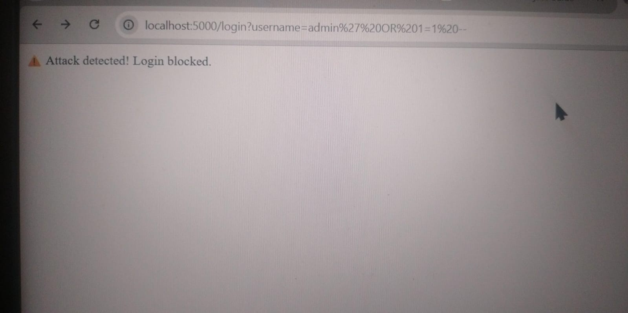
Figure 4: SQL Injection attack detected and login blocked.
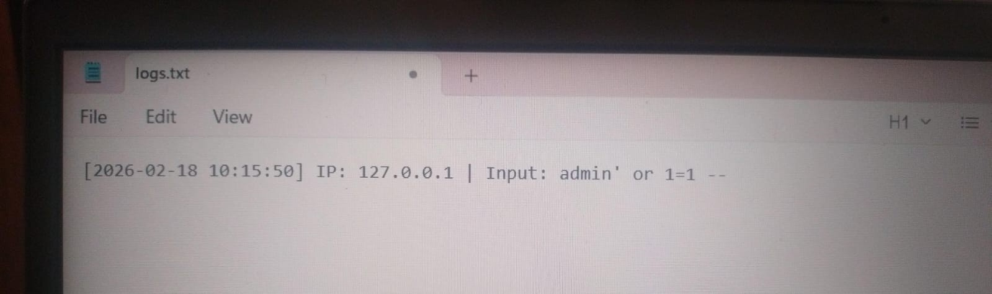
Figure 5: SQL Injection attempt recorded in the log file.
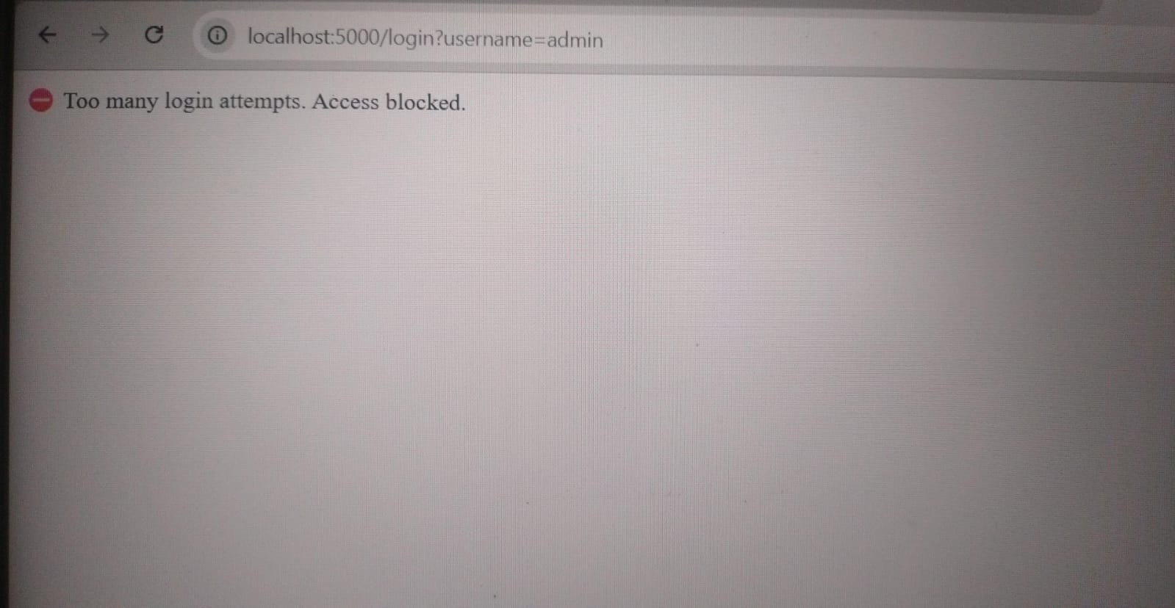
Figure 6: Brute-force login attempts blocked using rate limiting.
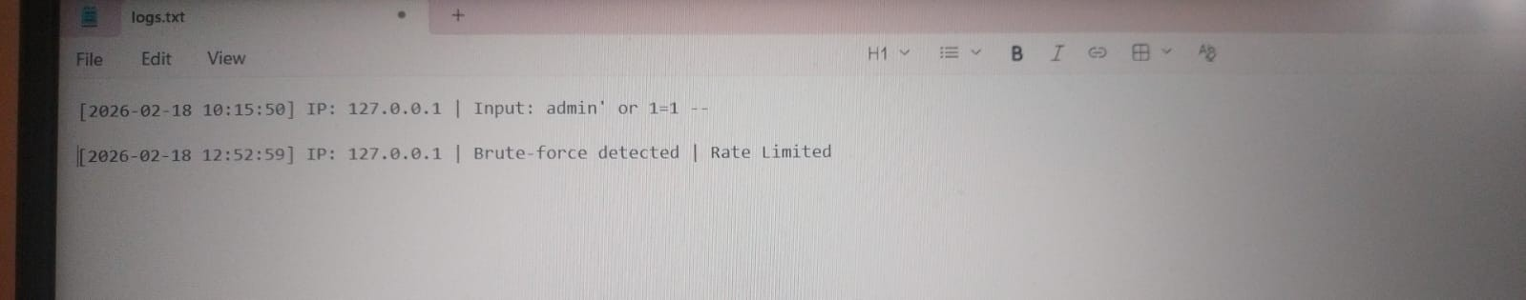
Figure 7: Brute-force activity recorded in the security log file.

Conclusion
SentinelShield successfully demonstrated the working of an Intrusion Detection and Web Protection System. The project provided hands-on experience in detecting web attacks, logging incidents, and preventing brute-force behavior.similar to real-world WAF systems.

